OFFICIAL COORDINATION REQUEST
FOR
NON-ROUTINE OPERATIONS AND MAINTENANCE

COORDINATION TITLE- 12LWG 010 U3 Exciter Tuning and Generator Model Validation Testing
COORDINATION DATE- July 6, 2012 UPDATED: 16 July 2012. Work to be performed between August 20 and Aug 31, 2012, as requested by FPOM 12 July 2012. See bold typing in description of the problem for answers to FPOM comments.

UPDATE: July 18, 2012:

No testing is currently planned to occur until January.

PROJECT- Lower Granite Lock & Dam

RESPONSE DATE- 12 July 2012 FPOM meeting.
Description of the problem:

Model Validation is required as a subset of rules under the Energy Policy Act and is required at least every 5 years by the Western Electricity Coordinating Council (WECC). It is required to show the generators will respond to an electrical grid emergency in a way that will prevent the Western grid from collapsing. Frequently, these tests reveal that generators control tuning has drifted and needs to be corrected for the safety of the electrical grid.

WECC unit Model Validation testing was due by December 31, 2011, but could not be accomplished since the unit has been out of service almost continuously since Jan, 2010 - first to be rewound, and then for cavitation repair. An attempt was made to complete testing in April, but several portions were not able to be completed, due to equipment failures during the test. The remaining portions of the test need to be completed, and exciter tuning needs to be completed first, or the test results will be invalidated. The exciter is what powers the rotor windings of the generator any time it is in service, and is a critical component.

An initial extension from the original deadline of December 31, 2011 was granted by WECC to extend the deadline to February 29. WECC granted a second extension to August 31. Extension applications require 90 days for processing. Failing to complete these tests can result in fines, penalties, sanctions, and potential grid instability, and will force operations to accept that risk or force unit 3 out of service. We are currently pursuing an extension through February 28, 2013 as our preferred course of action. This will be the third request for extension, and do not have any guarantee that it will be approved.

This test is completed by a contractor, as well as a sub-contractor exciter tuning consultant. With less than 2 weeks until the optimal test window for fish passage impacts, given the WECC August 31 deadline, there is almost no time left to negotiate the necessary contracts. Please expedite the response to this request so that we can have a viable alternative, should an extension not be provided by WECC.

Type of outage required:

A 2 week testing window is being requested between July 23 and August 3, 2012. (UPDATE: After July FPOM, recommendation: these test to be completed later in August The Corps will now move the tests to 20 Aug to 31 Aug). The total run time needed to conduct the tests is 16 hours. The 2 week window includes extra time to accommodate schedule coordination and unexpected delays for repairs. Outages will only be required when the unit is under test. During testing, unit priority will be maintained to the maximum extent possible. Because test equipment must be removed when not in use, 2 eight hour test periods are desired to ensure efficient use of contractor time and specialized test equipment. Note that transmission lines 1 and 2 Doble Tests are scheduled to take place at Lower Granite from August 13 – 16.

Impact on facility operation:

The unit is estimated to be out of service or under test for less than 16 hours (see the table below), including time for setup and takedown of instrumentation and test equipment when the unit will not be running.

Length of time for tests:
The total sum of the durations at various load levels is estimated as follows:

Expected time of U3 operation inside and outside1% criterion
Units | No Load (min) | Below 1% (min) | Inside 1% (min) | Above 1% (min)
3 | 90 | 300 | 180 | 60

Expected impacts on fish passage:

Below are graphs illustrating diel and daily passage of juvenile and adult salmonids at the Lower Granite Dam between July 15 and August 15. The juvenile charts were created using facility separator records for the years 2010 and 2011. The adult charts utilizes Corps hourly count and daily data for the years 2009, 2010 and 2011. Very few lamprey were counted during this period and no coho were seen.

Juvenile fish impacts should be minimized if work is conducted between 1400 and 2200 hours, when the fewest number of juvenile fish are present. Breaking the planned 16 hours of tests into two 8 hour blocks will be possible under this scenario. The first half of August appears to be the period in which the fewest number of juvenile salmonids are present. The amount of spill will not change and turbine unit priority will be maintained as much as possible during tests.

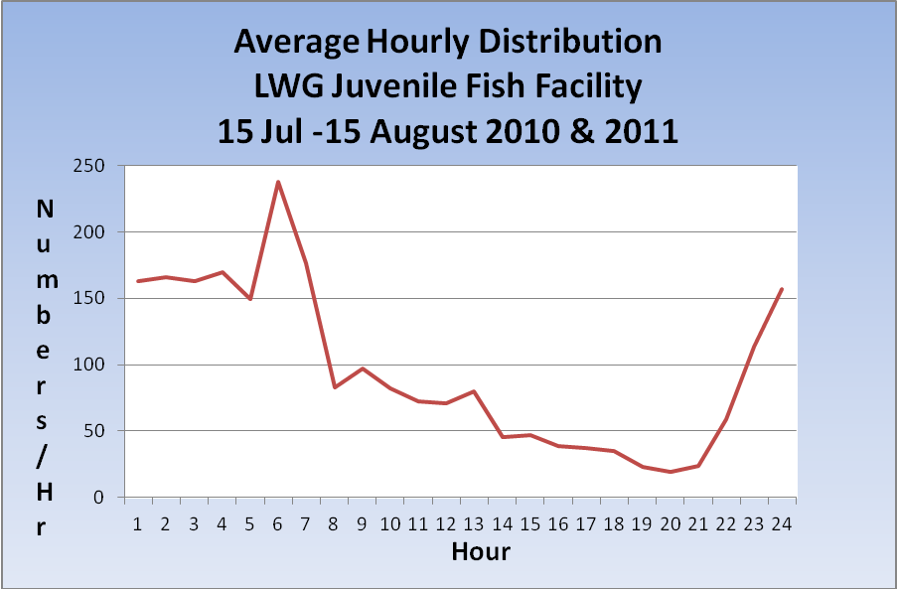

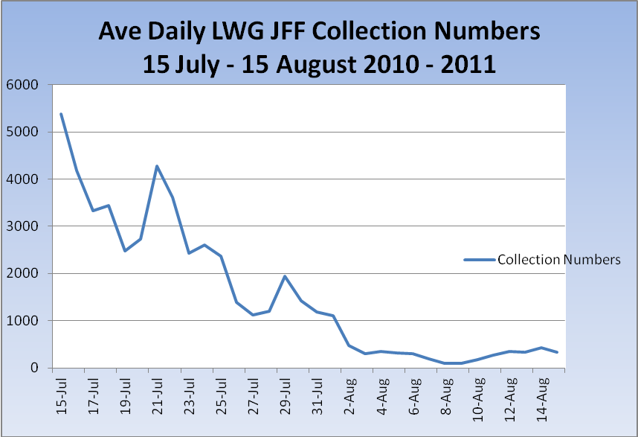

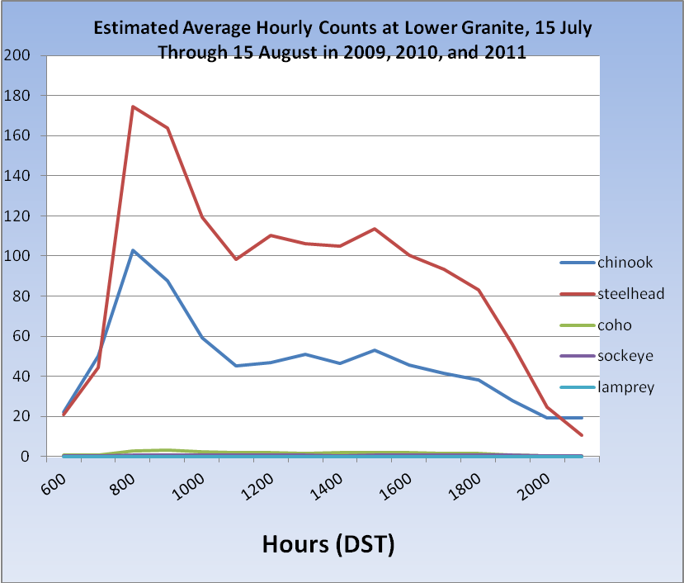

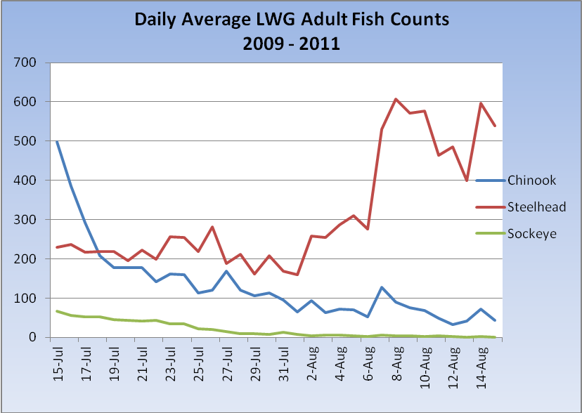

Adult fish passage impacts should be minimized if work is conducted during the afternoon and evening hours when fewer numbers of adult fish are present. If tests are shifted to late night and early morning hours, then juvenile fish passage will be more severely impacted. Mid to late July appears to be the period in which the fewest number of adult salmonids are present at lower Granite Dam. As mentioned above, the amount of spill will not change and turbine unit priority will be maintained as much as possible during tests.

Comments from agencies:
From draft FPOM 12 July 2012 minutes: 12LWG 010 U3 Exciter Tuning and Generator Model Validation Testing. Why can’t it wait until late August? Bettin says check with the crew to see if it’s possible to shift the schedule. Pending.

-----Original Message-----
From: Tom Lorz [mailto:lort@critfc.org]
Sent: Monday, July 16, 2012 11:48 AM
To: Moody, Gregory P NWW
Subject: Re: UPDATED 12LWG 010 U3 exciter coordination (UNCLASSIFIED)

thanks

tom

-----Original Message-----
From: Bettin,Scott W (BPA) - KEWR-4 [mailto:swbettin@bpa.gov]
Sent: Monday, July 16, 2012 2:35 PM
To: Moody, Gregory P NWW
Subject: RE: UPDATED 12LWG 010 U3 exciter coordination (UNCLASSIFIED)

Do they have a list of when they are due on all the other units in the Walla Walla district? It would be nice to know when we need to get them accomplished and shape the schedule now if there are a slew of them on the horizon. -s

Final results:

Now rescheduled for the period between 20 Aug to 31 Aug.
The Corps is requesting an extension of the WECC deadline of 31 August to 28 Feb 2013. See above in bold letters in the project description for updates to FPOM comments.

-----Original Message-----
From: Brooks, Gregory S NWW
Sent: Wednesday, July 18, 2012 2:40 PM
To: Watkins, Maggie I NWP; Wall, Robert NWW
Cc: Bouwman, Brandon J NWP; Berger, Michael J NWP; Musser, Rowena L NWP; Wall, Robert NWW; Moody, Gregory P NWW; Lustig, Robert L NWW
Subject: RE: Lower Granite (UNCLASSIFIED)

Classification: UNCLASSIFIED
Caveats: NONE

Maggie,

Rob let me know today that WECC will extend the test deadline for us until the end of February. With this in mind, we would like to test in early January at Lower Granite. Please advise HDR.

Thanks,
Greg

Thank you,
John Bailey
509-527-7123

